**Project Design Phase**

**Solution Architecture**

| Date | 30 August 2025 |
| --- | --- |
| Team ID | LTVIP2025TMID60971 |
| Project Name | DocSpot: Seamless Appointment Booking for Health |
| Maximum Marks | 4 Marks |

**Solution Architecture:**

The solution architecture for **DocSpot** ensures a robust, user-friendly, and scalable platform that connects patients with healthcare professionals for seamless appointment booking. The architecture focuses on **responsive design, secure authentication, real-time notifications, and efficient scheduling** to provide a smooth healthcare experience.

**Key Features in the Architecture:**

* **Easy appointment booking & cancellation** with doctors.
* **Real-time availability tracking** for doctors.
* **Scalable patient & doctor authentication/authorization.**
* **Secure and trackable payment integration.**
* **Real-time reminders & notifications** (SMS/Email/App).
* **End-to-end healthcare lifecycle management.**
* **Medical history storage & quick access for doctors.**

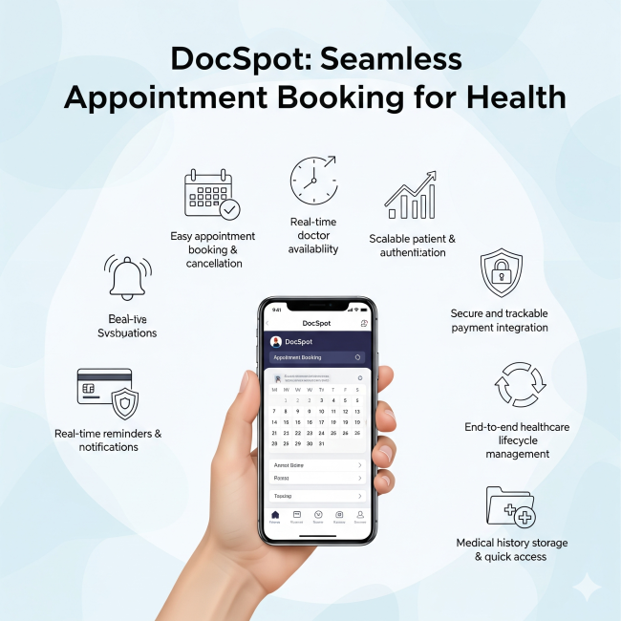

**Example - Solution Architecture Diagram:**

